**Mind Reader Game User Manual**

1. Start the Mars Application
2. Open MindReader.asm
3. Assemble the program
4. Select “Tools” from the top menu bar.
5. Select “Bitmap Display” from the “Tool” drop-down menu.
6. 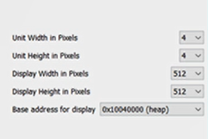Select the values below for their respective fields the Bitmap Display dialogue box.

“**Display Width in Pixels**” = “512”

“**Display Height in Pixels**” = “512”

“**Unit Width in Pixels**” = “4”

“**Unit Height in Pixels**” =“4”

“**Base address for display**” = 0x1004000(heap)

**It should look like this:**

1. Now select “run”
2. With the program running select push ‘y’ if your number is displayed in the window for the current card and push ‘n’ if it is not.
3. After you have gone through the 6 cards selecting ‘y’ or ‘n’ for when your number is displayed on the card, the number you had in mind should now be displaying.
4. If you would like to play again select ‘y’ and if you don’t want to play again select ‘n’.